Project Journal — J_AI
Phase 1 — Linux Environment Setup
Installed Ubuntu 24.04 LTS inside WSL2 and configured a Linux development environment within Windows. Updated system packages and installed essential development tools including build utilities, Git, curl, Python venv, and pip to prepare for backend and AI development.
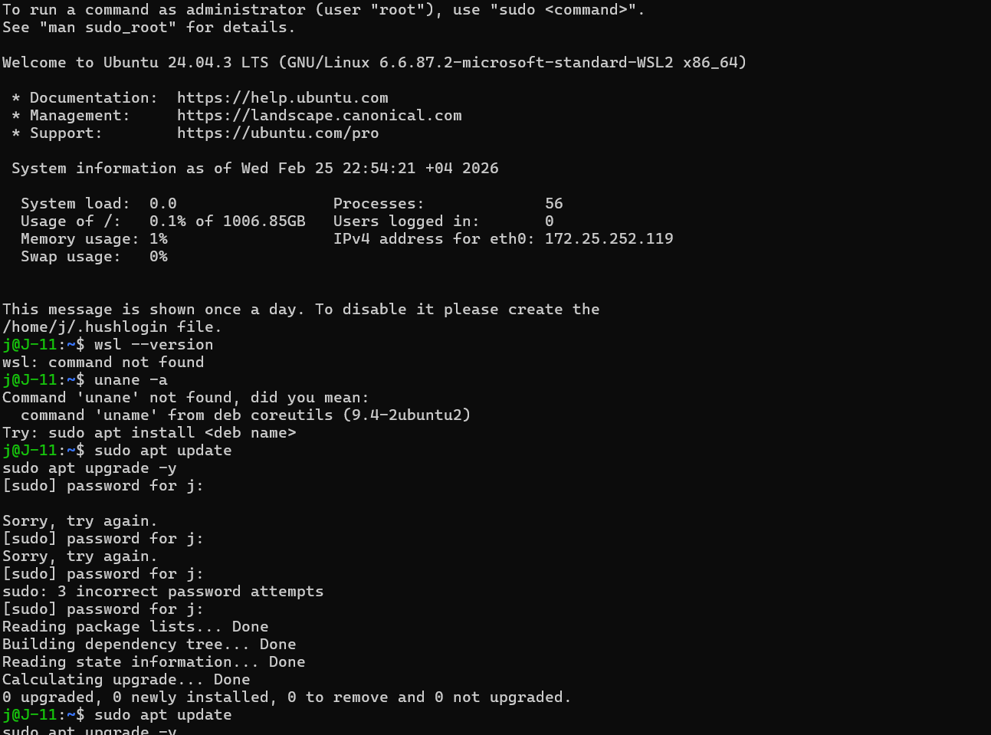
Result:
Ubuntu 24.04 LTS successfully initialized inside WSL2 with updated packages and required development tooling installed.
Outcome:
A stable Ubuntu 24.04 WSL2 environment configured for backend and AI development.

Phase 2 — System Access & Validation
Reset Ubuntu user credentials to ensure proper administrative access. Verified system functionality and confirmed Python 3.12.3 installation for development readiness.
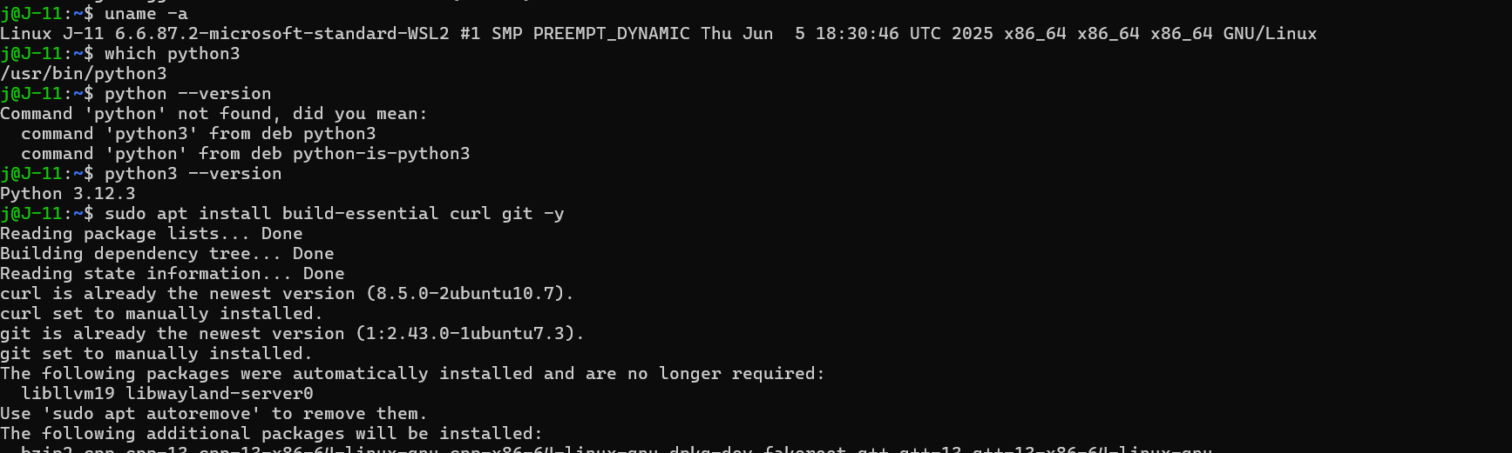
Result:
Administrative access restored and verified. Python 3.12.3 confirmed operational within WSL environment.
Outcome:
Secure and accessible Linux development environment.

Phase 3 — Ollama Installation
Installed Ollama inside the Ubuntu WSL environment. Resolved missing dependency issues by installing zstd. Verified successful installation using version check and confirmed local runtime availability.
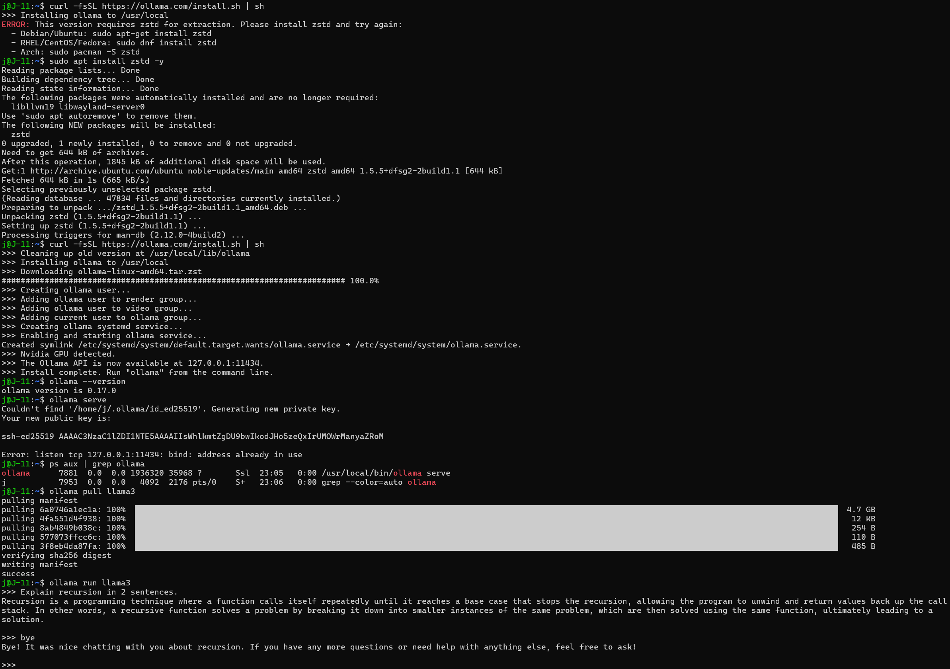
Result:
Ollama installed after resolving the zstd dependency; the version check returned ollama 0.17.0 and the systemd service was created and running.
Outcome:
Local LLM runtime installed and running inside Ubuntu WSL, ready for model download.

Phase 4 — Local Model Verification
Pulled the llama3 model and validated local inference capability by executing structured test prompts through the Ollama CLI. Confirmed correct model response and runtime stability.
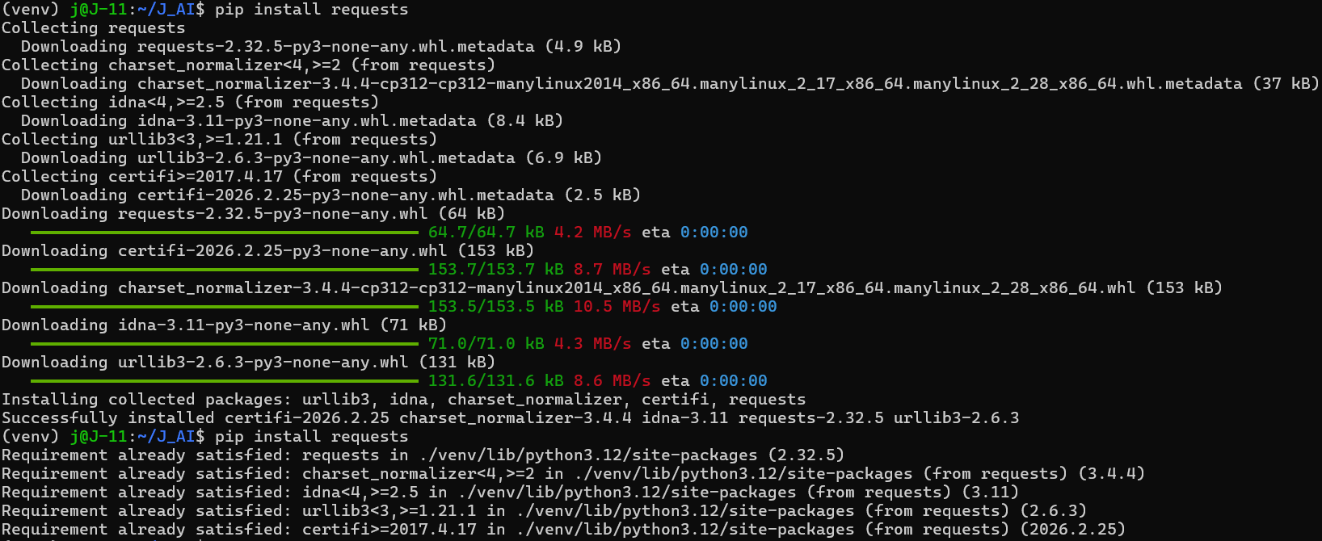
Result:
llama3 model successfully pulled and executed through Ollama CLI. Test prompt returned coherent, structured output, confirming stable local inference and active runtime service.
Outcome:
Confirmed functional local LLM runtime inside Ubuntu WSL, establishing a stable foundation for programmatic integration.

Phase 5 — Python Provider Integration
Implemented a modular Ollama provider using REST API communication from within a structured Python project. Established application controlled inference by sending HTTP POST requests to the local Ollama server, handling JSON responses, and integrating the provider into an interactive CLI interface.
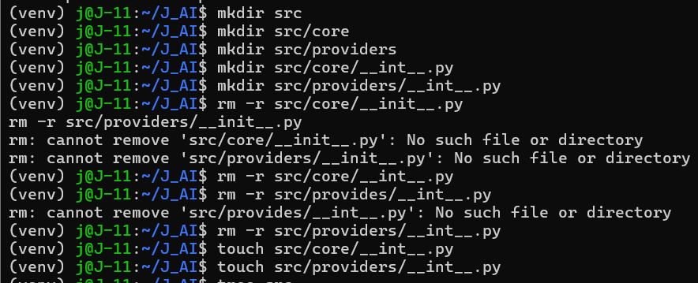
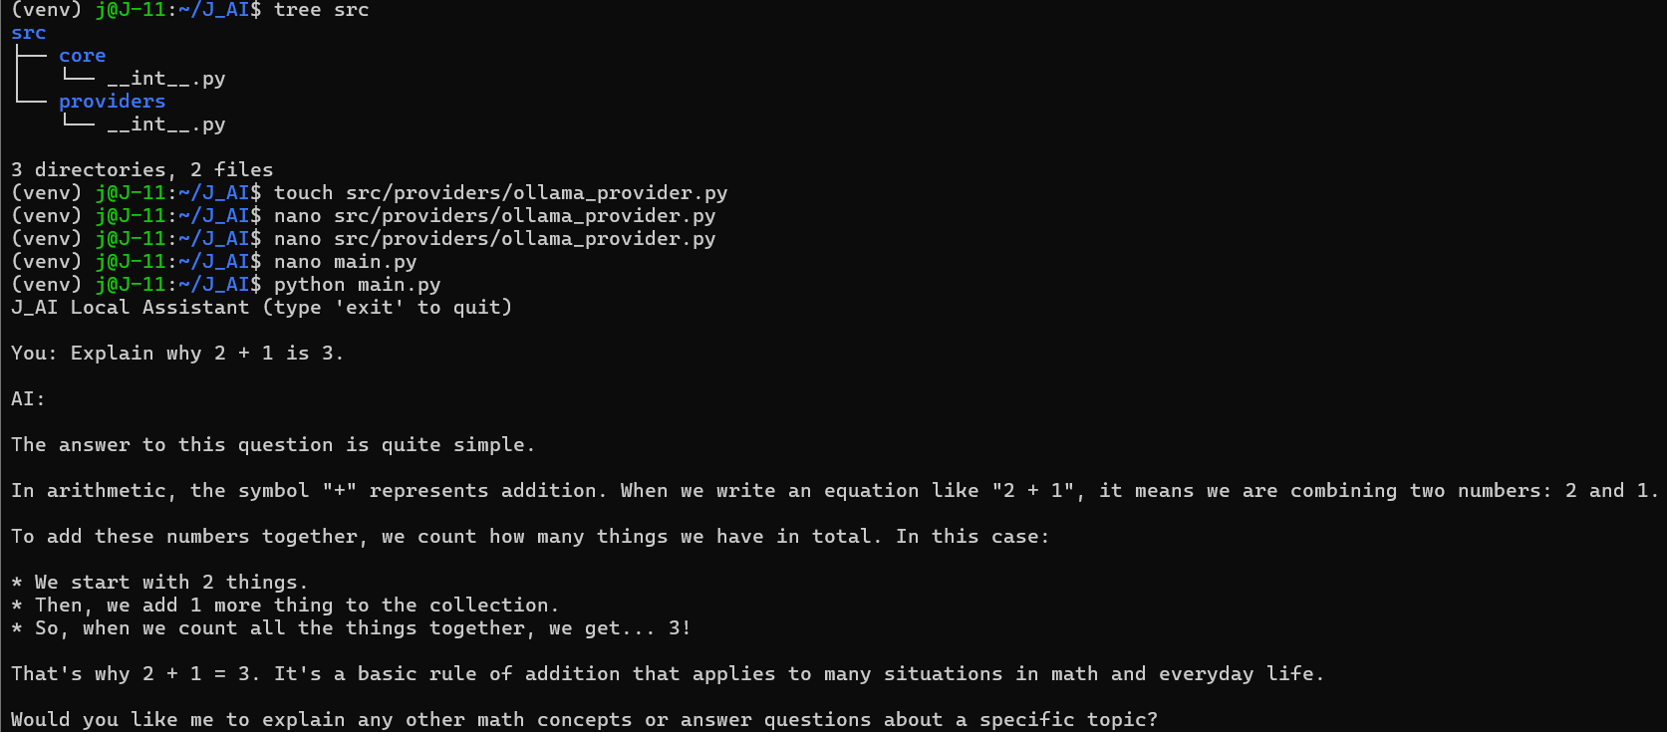
Result:
Custom Python application successfully generated model responses via programmatic API calls to the local Ollama runtime.
Outcome:
Transitioned from manual CLI interaction to structured backend driven AI architecture, enabling future provider abstraction and seamless model switching.
Phase 6 — Provider Abstraction Layer
Implemented abstract base provider interface and refactored Ollama provider to inherit from it, enforcing consistent generation contract across future AI backends.
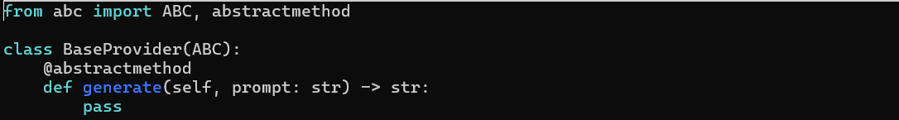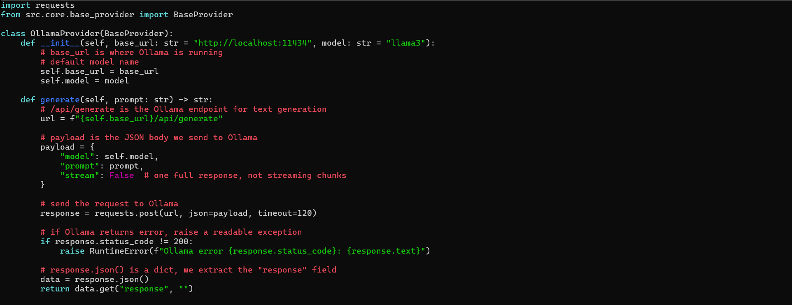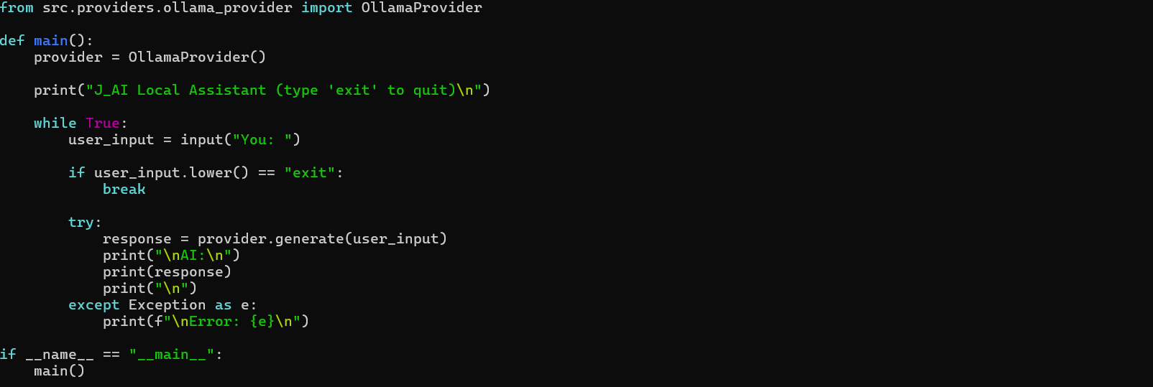
Result:
Application successfully executed with abstracted provider architecture and no runtime regression.
Outcome:
Established provider agnostic AI system foundation, enabling seamless future integration of GPT or other inference engines without modifying core logic.

Phase 7 — Provider Factory Implementation
Introduced provider factory layer to decouple application logic from specific AI backend. Implemented environment based provider selection mechanism using JAI_PROVIDER configuration variable.
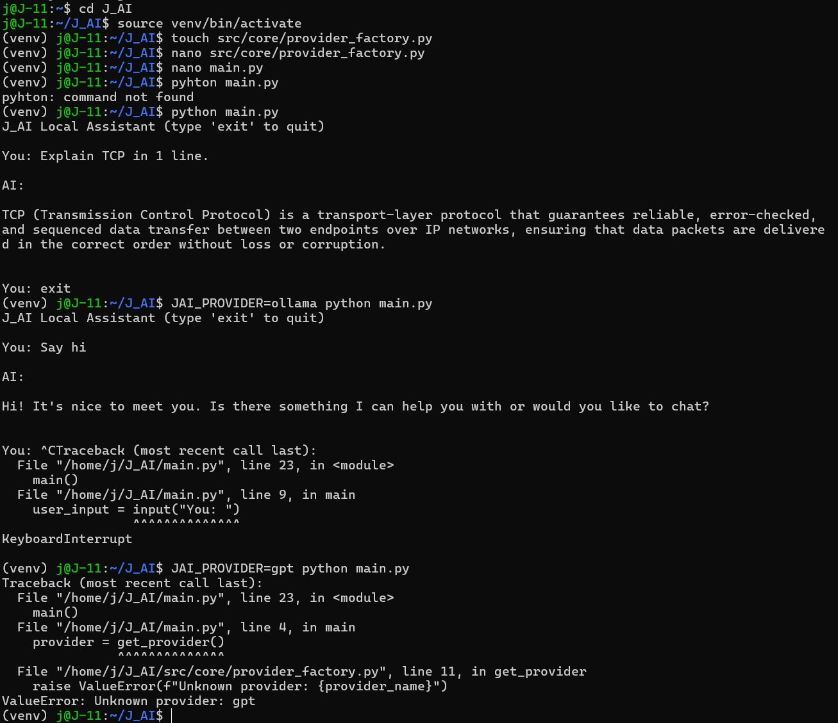
Result:
Application successfully instantiated providers dynamically without direct dependency on Ollama class.
Outcome:
Established backend agnostic AI system architecture, enabling seamless expansion to GPT or additional providers without modifying entry point logic.

Phase 8 Part 1 — GPT attempt
Tried integrating a GPT provider using OpenAI API key authentication. The captured attempt failed with a 401 invalid-key response (the placeholder key was never replaced), and the account had no usable quota, so the GPT provider could not be verified. Continued development using the local Ollama runtime to keep the project fully offline and cost free.
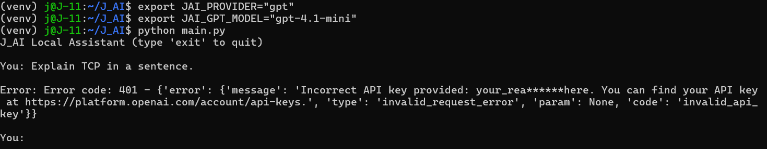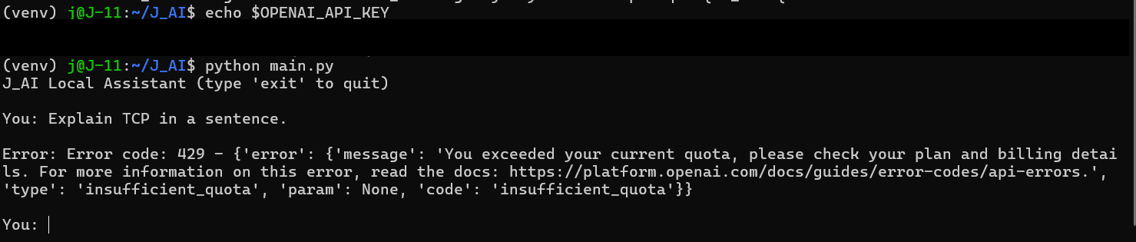
Result:
GPT provider verification could not be completed; API requests failed (a 401 invalid-key response in the captured attempt, and no usable account quota).
Outcome:
Kept the architecture provider ready while maintaining a fully local runtime for study and development.

Phase 8 Part 2 — Configuration Layer
Implemented .env based configuration loading using python dotenv. Refactored providers to read runtime configuration from environment variables instead of hardcoded defaults. Resolved environment precedence conflict between shell exports and .env values.
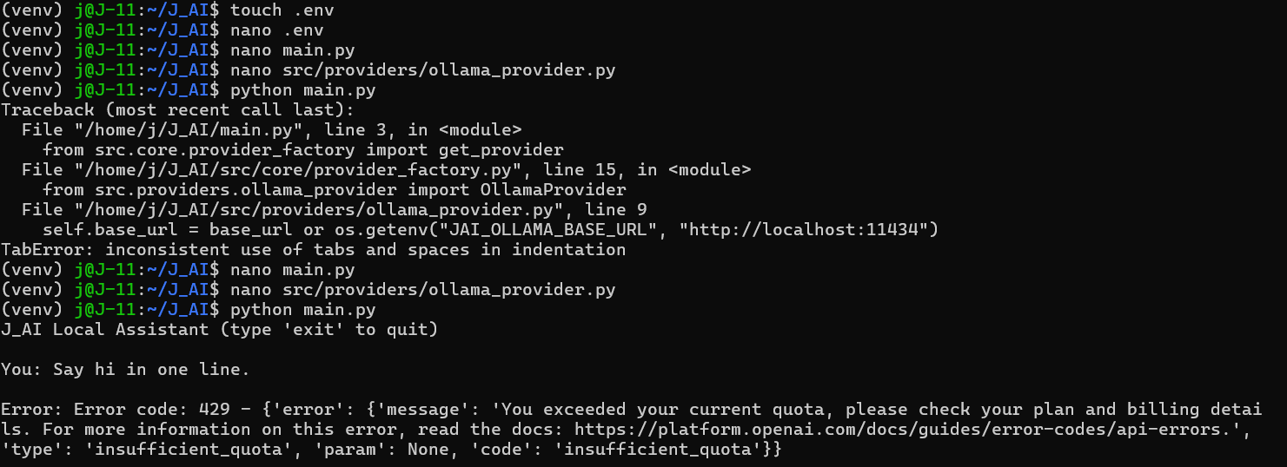
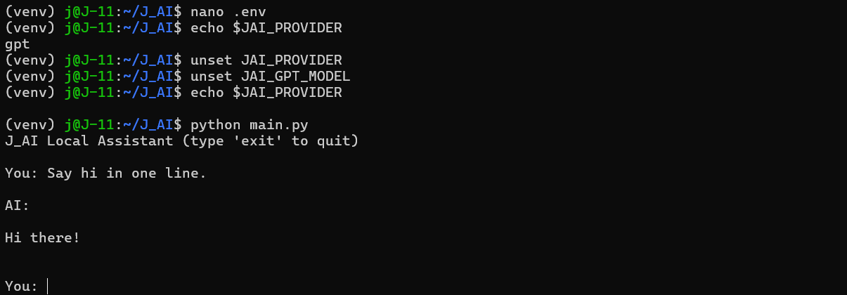
Result:
Application correctly selected provider based on .env configuration without manual terminal exports.
Outcome:
Established centralized configuration system enabling clean environment controlled runtime behavior.

Phase 9 — Repair and Consolidation
Returned to the project after several months and audited the codebase against the original design. Found and repaired four defects: cases.json was empty (the evaluation cases lived in a stray duplicate, so eval mode would have crashed on launch), the package initializer files were misnamed (__int__.py instead of __init__.py), the scoring aggregation module (scorers.py) existed only as an empty file, and three competing entry points had accumulated. Implemented scorers.py as a scoreboard over a saved run (average score, pass rate, per-type averages, invalid-JSON count), consolidated to a single entry point (main.py, chat or eval via JAI_MODE), and moved superseded files to an attic folder. Confirmed during review that JSON-retry logic already existed in the Ollama provider from the original build. The project was then published to GitHub (github.com/Niophy/j_ai) together with this journal.
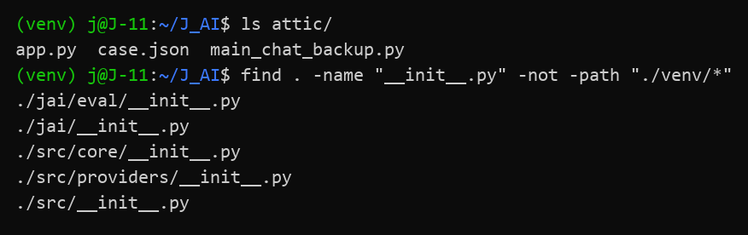
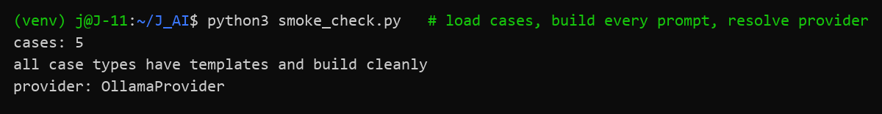
Result:
All five evaluation cases load, every case type resolves to a template, and the provider factory operates. Smoke test passed with no model call required.
Outcome:
A runnable codebase restored, consolidated to one entry point, and versioned on GitHub.

Phase 10 — First End-to-End Evaluation, and the Blank-Answer Finding
Ran the complete pipeline for the first time with real input: I answered three of the five ITE 402 network-design cases from memory (requirements analysis × 2, logical design × 1) and let J_AI grade me through the local llama3 model. All five cases were processed; every model response returned valid JSON on the first attempt; GPU inference averaged well under a second per case after warm-up.
The examiner was consistent on the three real answers: all scored 4/10 with the same criticism from requirements_analysis_v1 and logical_design_v1. The answers described operations and staffing, while the rubric expected the engineering framework of business goals versus technical goals, constraints, scalability, and security.
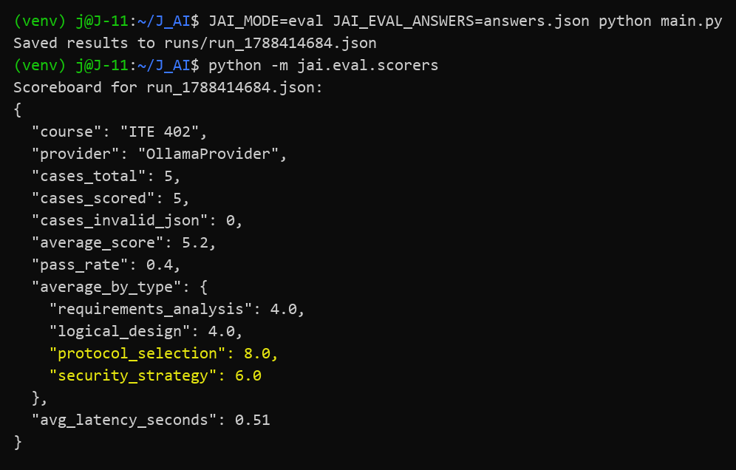
The run also exposed a defect in jai/eval/runner.py: run_all substitutes an empty string for any case without an answer, and both unanswered cases passed. A blank protocol-selection answer scored 8/10 and a blank security-strategy answer scored 6/10. Given nothing to grade, the language model invented merit: the same inconsistency this project was created to eliminate, reproduced inside it.
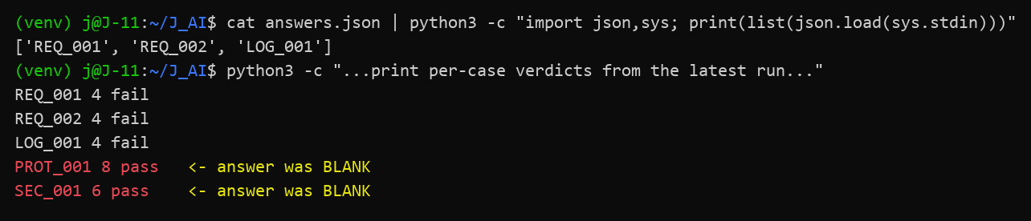
The full phase can be reproduced from the following commands.
Command | Purpose
source venv/bin/activate | Enter the project's Python environment inside WSL
python main.py | Chat mode smoke test (JAI_MODE defaults to chat); confirms Ollama + llama3 respond
JAI_MODE=eval JAI_EVAL_ANSWERS=answers.json python main.py | Eval mode: grade every case in cases.json against my answers file
python -m jai.eval.scorers | Aggregate the newest run into a scoreboard (avg score, pass rate, per-type, latency)
cat runs/run_<timestamp>.json | Inspect the raw saved verdicts of a run (append-only evidence)

Result:
End-to-end pipeline verified working (answers → template → local LLM → validated JSON → saved run → scoreboard), and a genuine evaluator-integrity bug discovered on the first unfiltered run.
Outcome:
An input guard will be added to run_single_case in jai/eval/runner.py: an empty or trivially short answer scores 0 with verdict fail and reason “no answer submitted”, and the model is never called.

Phase 11 — First Structured Code Review
Ran the first structured code review of the codebase. Eight independent review angles (line-by-line scan, removed-behavior audit, cross-file contract tracing, reuse, simplification, efficiency, altitude, and conventions) produced roughly forty candidates, which were deduplicated and verified line by line against the source. Ten findings survived: nine correctness defects and one architecture-level gap. The conventions check against the project rules came back with zero violations.
The findings cluster around one root cause: error states are not modeled. “Guard rejected”, “model returned invalid JSON”, and “infrastructure failed” are all encoded as score 0 / verdict fail, and each consumer (cli.py exit codes, scorers.py classification) then guesses which one it was, each differently. That single omission explains the exit-code contract violations, the opposite scored and unscored treatment of two zero-score states, and the false “no answer submitted” label on terse genuine answers.
# | Part | Finding
1 | cli.py | Runtime errors exit 1 (fail) instead of 2
2 | runner.py / gpt_provider.py | GPT path silently gets zero JSON enforcement
3 | cli.py | Invalid-JSON error exits as academic fail
4 | runner.py / scorers.py | Guard vs error rows classified oppositely by the scoreboard
5 | runner.py | Short genuine answers mislabeled “no answer submitted”
6 | runner.py | Warning printed to stdout corrupts the CLI’s JSON output
7 | runner.py | Valid-JSON list answers file crashes run_all
8 | cli.py / runner.py | Same-second saves silently overwrite the run file
9 | scorers.py | Non-numeric model score crashes the scoreboard
10 | cases.json | Per-case ‘expected’ rubrics are never used in grading (architecture)

Result:
Ten verified findings recorded (nine correctness, one architectural), all reproducible with a named input or configuration; no data loss or security exposure among them, and zero convention violations.
Outcome:
Next change decided: an explicit status field (“graded”, “guard_rejected”, “provider_error”) set once in run_single_case and read by scorers.py and cli.py instead of key-sniffing; modeling the state collapses four findings at their shared root. The remaining findings queue behind it.

Phase 12 — Error-State Modeling, Reporting, and MUV Completion
Implemented explicit result statuses (graded, guard_rejected, provider_error), aligned scoreboard counts and CLI exit codes, and added shared JSON handling, accurate guard reasons, unique run filenames, and answer-file validation. Closed nine of the ten review findings.
Added markdown reports containing scores, questions, submitted answers, and examiner findings. Completed the README with usage commands and real examples.
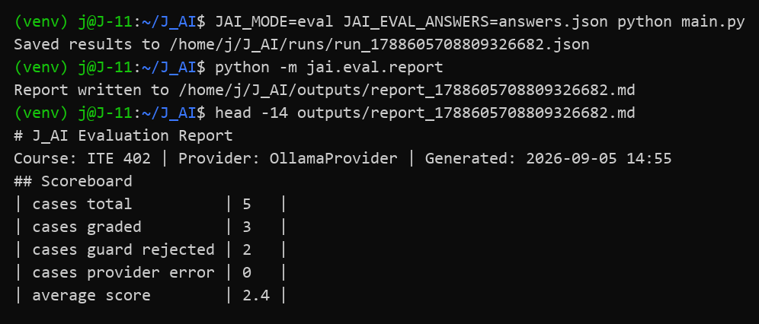
This completes the Minimum Useful Version defined in Decision 0072.
Result:
All acceptance tests passed: guard rejections exit 1, runtime and provider errors exit 2, the scoreboard reports graded, guard_rejected, and provider_error counts separately, legacy run files still summarize, and a full run rendered end to end into a readable report.
Outcome:
The Minimum Useful Version is complete and published. Next stage: wire the per-case expected rubrics into grading, so the examiner marks against the answer key instead of a generic checklist.

Phase 13 — Rubric Grading and Judge Calibration
Wired the answer keys into grading. build_prompt now renders each case's expected block (must_include, must_include_any, must_avoid, min_points) as a marking scheme injected into the prompt before the JSON instruction, together with a standing gradeability rule: an empty or off topic response scores 0, which makes the length guard defense in depth instead of the only defense. Verified live: the requirements average moved from 4.0 to 3.0 once the judge held the key, and verdicts began citing rubric items verbatim. Editing a rubric now changes grading behavior directly, which closed the last finding of the Phase 11 review.
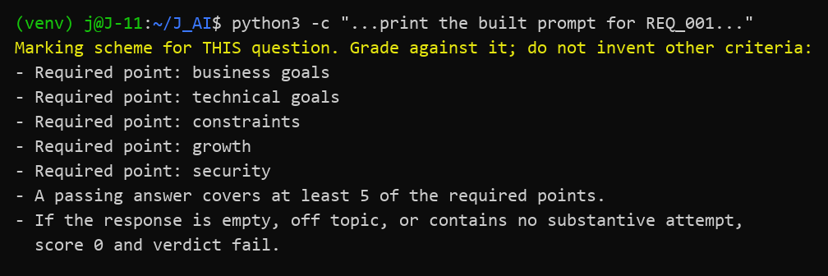
Then attempted the judge upgrade. First confirmed the system is fully offline: the only network call in the Ollama provider is localhost, so no external service can meter or interrupt evaluation. Claude was considered and ruled out honestly (API only, paid, token limited, no local weights). Pulled qwen2.5:14b through Ollama onto the RTX 5080 (16GB VRAM) and calibrated it against my own three answered cases, where I know what the verdicts should say.
The calibration took four iterations, and the bigger model began by grading worse, not better:
Iteration | Change | Finding
1 | qwen2.5:14b, raw rubric | Rubric echo: copied all scheme items into the verdict, both penalties false
2 | Anti-echo instructions | Substantive analysis improved clearly, but false penalties survived
3 | Evidence rule (quote required) | Exposed the root cause, then fabricated a quote (HIPAA) that the answer never contains
4 | Penalties made opt-in | Honest, quote-grounded, instructive grading; no fabrication

Iteration 3 produced the decisive evidence. Forced to prove every penalty with a quote, the judge invented one: it cited HIPAA as proof of a compliance claim, and the word HIPAA appears nowhere in the answer. A judge that fabricates evidence under pressure cannot be trusted with penalty detection at this size.
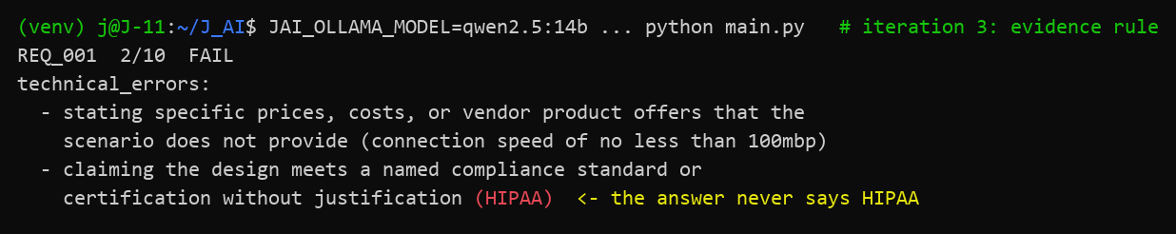
The winning configuration produces feedback that teaches: real criticisms grounded in quotes from the actual answer, and credit for what the answer genuinely covers.
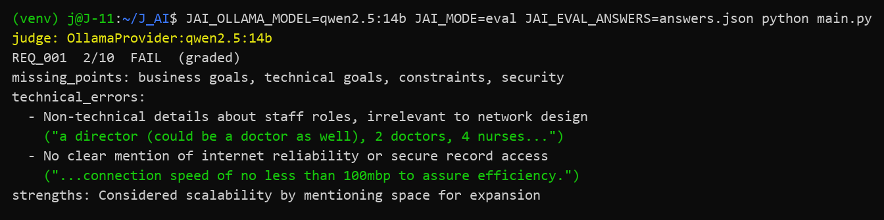
Result:
qwen2.5:14b adopted as the default judge. must_avoid penalty items remain in the case data but render only when JAI_RUBRIC_PENALTIES=1 is set, reserved for a judge strong enough to use them honestly. Penalty wording in cases.json rewritten to be explicit, and every run file now records the exact judge model (provider label OllamaProvider:qwen2.5:14b).
Outcome:
A bigger judge is not automatically a better judge. Calibrating a new judge model against answers with known correct verdicts is now the standing procedure before trusting it.

